**In-silico system biology- (PRACTICAL)**

**EXPERIMENT :** Determine protein-protein interaction information using APID.

**Submitted by: PRIYANKA PILANIA**

**M.Sc BIOINFORMATICS**

**Enrollment no: A0500320009**

**Aim**: Determine protein-protein interaction information using APID.

**About APID:**

* Agile Protein Interaction DataAnalyzer (APID) is an interactive bioinformatics web tool developed to integrate and analyze in a unified and comparative platform main currently known information about protein–protein interactions demonstrated by specific small-scale or large-scale experimental methods. At present, the application includes information coming from five main source databases enclosing an unified sever to explore >35 000 different proteins and 111 000 different proven interactions. The web includes search tools to query and browse upon the data, allowing selection of the interaction pairs based in calculated parameters that weight and qualify the reliability of each given protein interaction. Such parameters are for the ‘proteins’: connectivity, cluster coefficient, Gene Ontology (GO) functional environment, GO environment enrichment; and for the ‘interactions’: number of methods, GO overlapping, iPfam domain–domain interaction. APID also includes a graphic interactive tool to visualize selected sub-networks and to navigate on them or along the whole interaction network.
* It as accessed through <http://cicblade.dep.usal.es:8080/APID/init.action>
* APID server was built with a **protein** and **proteome-centered** strategy, using **UniProt** database as the main guide to identify and handle all the proteins and to map them into the reference proteomes of each species (based on the new proteomes resource that UniProt has recently developed: [http://www.uniprot.org/proteomes/](http://www.uniprot.org/proteomes/" \t "http://cicblade.dep.usal.es:8080/APID/_blank)).

**Interaction information:**

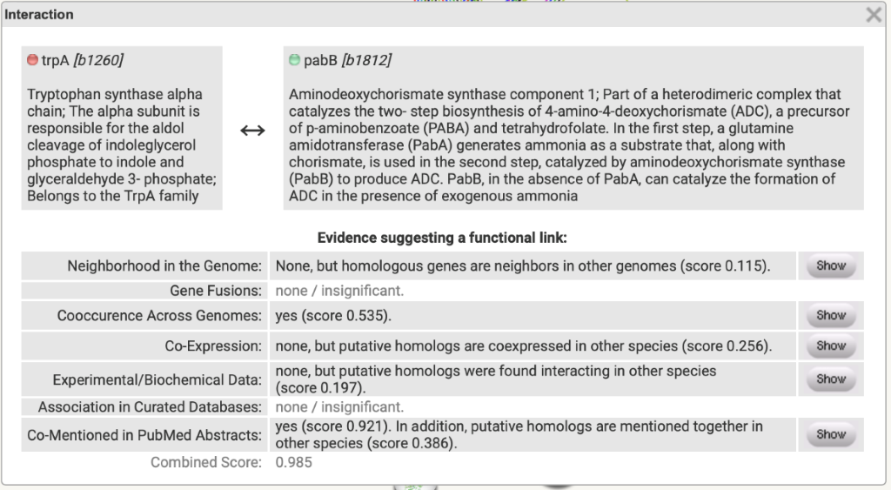

Agile Protein Interactomes DataServer: It has curated protein interactomes, PPIs demonstrated by experimental methods, graphic interactive tool to visualize selected sub-networks. It uses various databases involved such as DIP, PDB, SwissProt, and annotation databases such as Reactome.

**PROCEDURE:**

1. In APID database, we can get the information about the interactomes at different quality levels and coverage in PROTEOMES, we can either search one particular protein or list of different proteins and we can also search for publications using pubmed ID. Here, in the protein search section we enter the protein name and click on search.

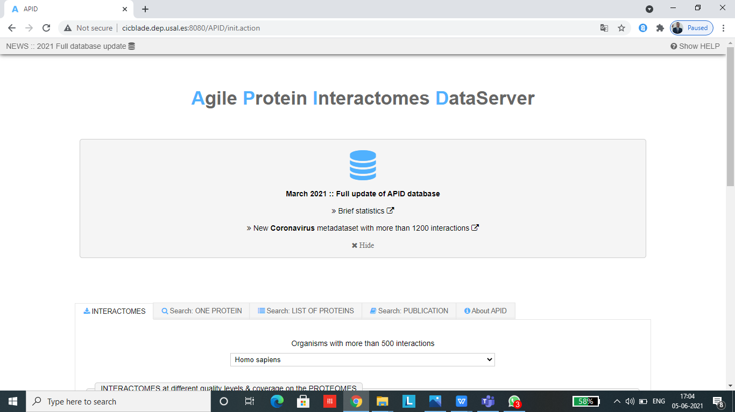

1. Upon searching for an interactome at a given level, a text file in tabular format is downloaded onto the system. The table contains UniProt name and ID, and 3D structure.

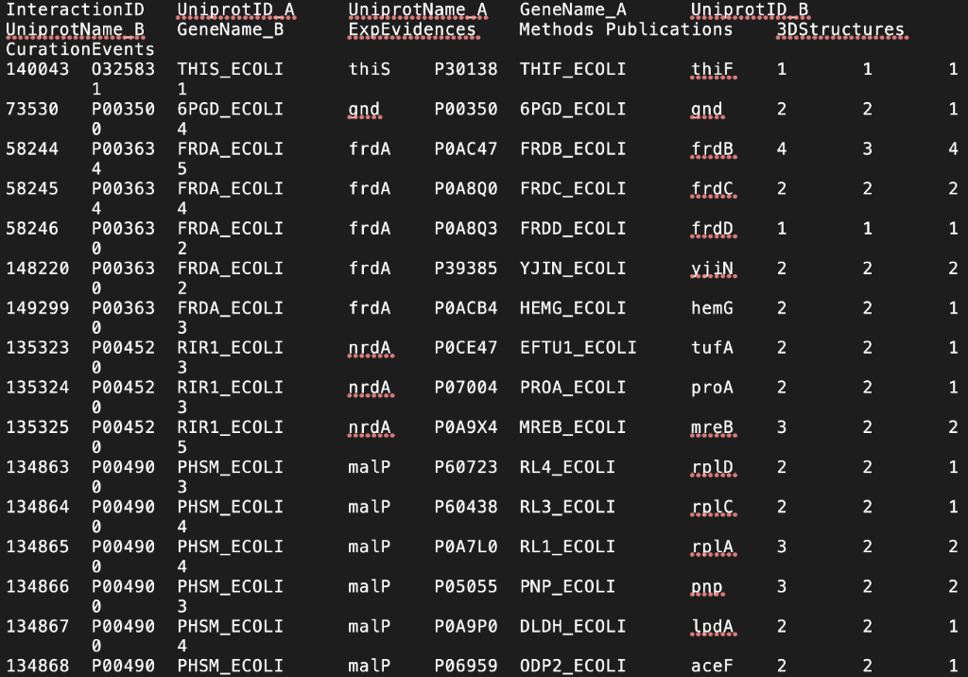

1. We can look for the protein interactions by clicking on interactions.

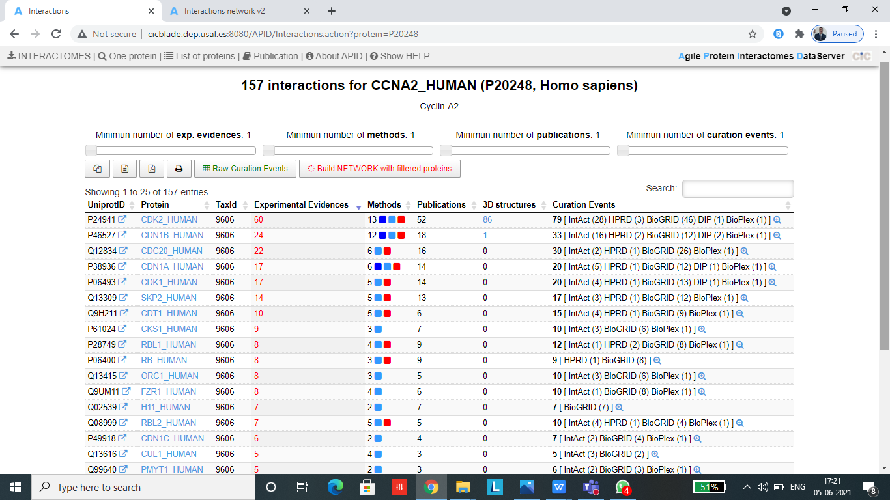

1. We can also look for the curation events.

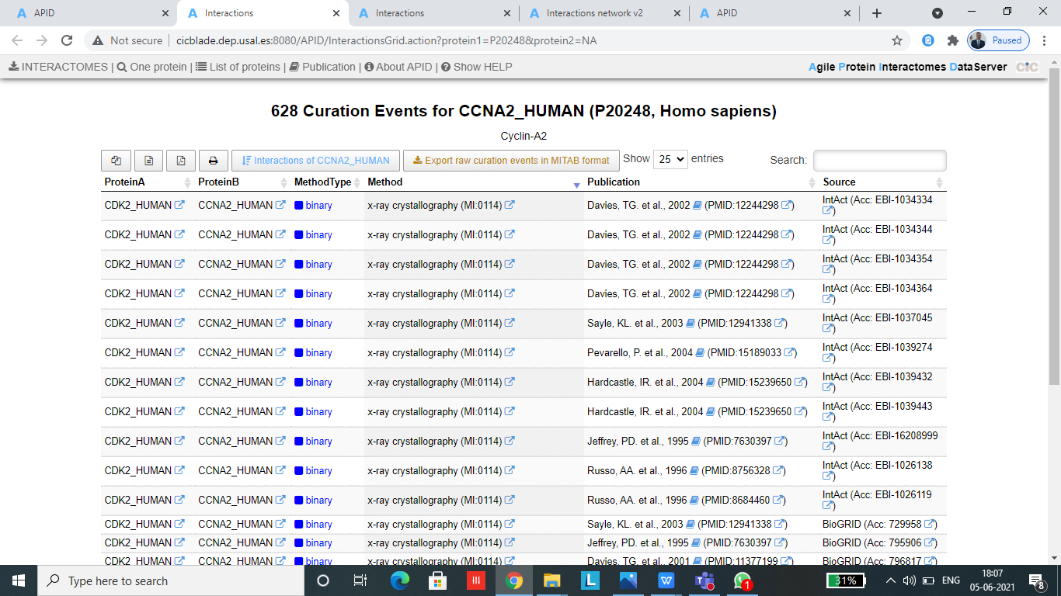

1. We can then build network by using the filtered proteins and can look for the interactions.

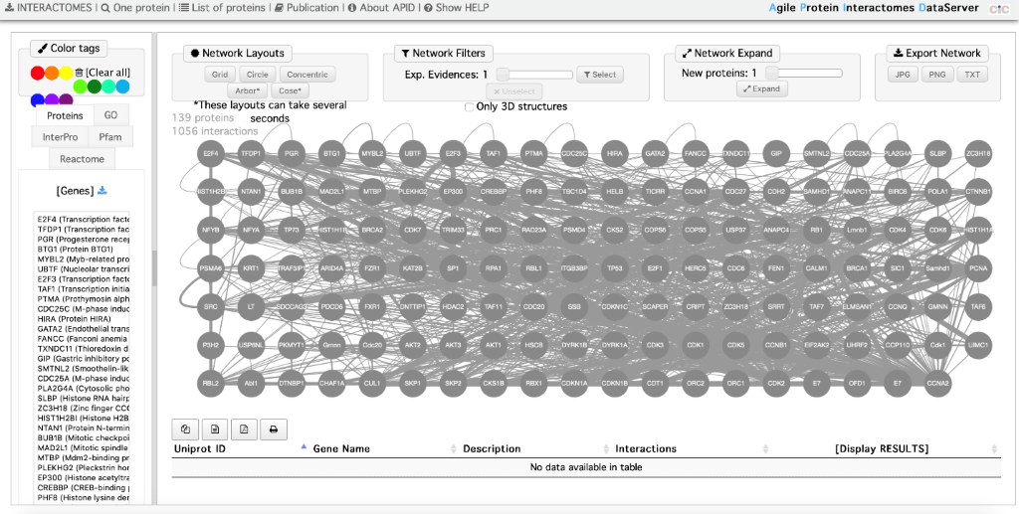

1. Upon searching for a specific protein, we can come across the above with all the relevant information.
2. We can also access the interaction network as well as take a look at the genes available. We can click on any individual protein in order to obtain information about it as well as the interactions.
3. APID also allows users to build interactome for a list of proteins. This is done so through preparing a list of proteins using UniProt name identifiers or ENTREZ. Once the proteins are found, the list will be shown on a new window. Using this list, a protein network can be built.